DDL Commands :
1. Table Creation (CREATE): Write the SQL statements to create a database named
“employee” and the following tables based on the provided schema:
⦿ Departments
⦿ Location
⦿ Employees
CREATE DATABASE Employee;
USE employee;
- CREATE TABLE Departments(
department_id int PRIMARY KEY, department_name VARCHAR(100)
);
- CREATE TABLE Location(
location_id int PRIMARY KEY, location VARCHAR(30)
) ;
- CREATE TABLE Employees(
employee_id int PRIMARY KEY,
employee_name VARCHAR(50),
gender ENUM('M','F'),
age int,
hire_date DATE,
designation VARCHAR(100),
department_id INT,
location_id int,
salary DECIMAL(10,2),
foreign key(department_id) REFERENCES Departments(department_id),
foreign key(location_id) REFERENCES Location(location_id)
)
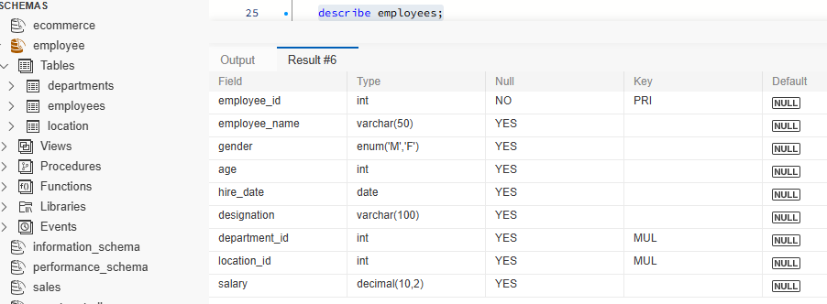

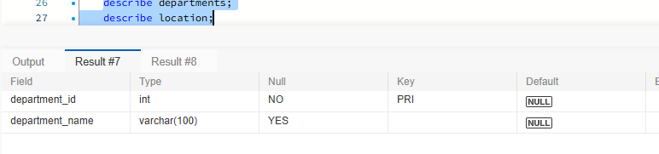
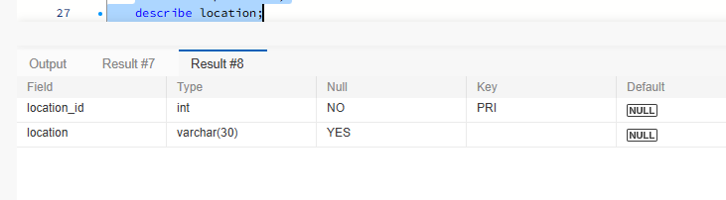

2. Table Alteration (ALTER): Consider the following scenarios and write the SQL statements to alter the structure of the tables accordingly:
⦿ Add a new column named "email" to the Employees table to store
employee email addresses.
ALTER TABLE employees ADD COLUMN Email VARCHAR(100);
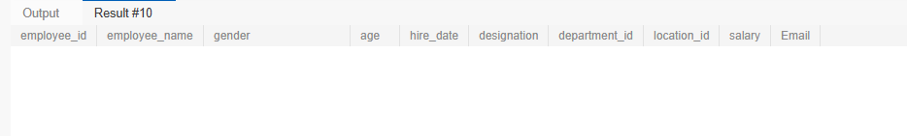

⦿ Modify the data type of the "designation" column in the Employees table to support a wider range of values.
ALTER TABLE employees MODIFY COLUMN designation VARCHAR(255);
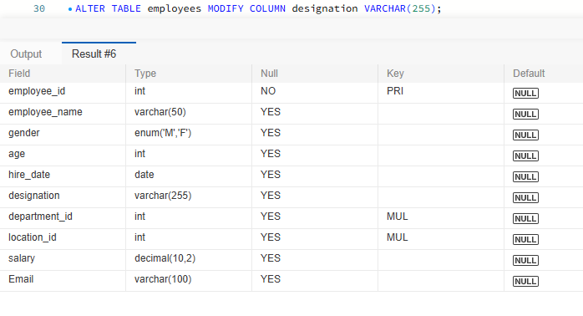
⦿ Drop the “age” column from the Employees table.
ALTER TABLE employees DROP COLUMN age;
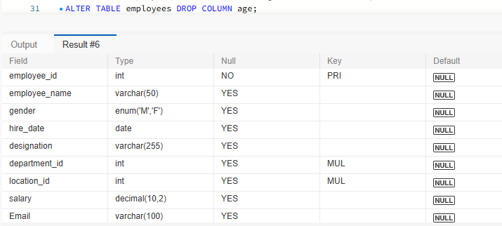

⦿ Rename the “hire_date” column to “date_of_joining”.
ALTER TABLE employees RENAME COLUMN hire_date TO Date_of_joining;
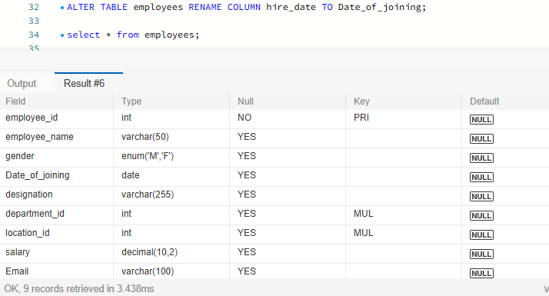
3. Table Renaming (RENAME): Rewrite the SQL statements to rename the
following tables:
⦿ Rename the "Departments" table to "Departments_Info".
RENAME TABLE departments TO Departments_Info;
⦿ Rename the "Location" table to "Locations".
RENAME TABLE departments TO Departments_Info;
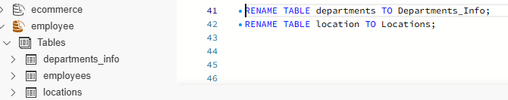

4. Table Truncation (TRUNCATE): Write an SQL statement to truncate the Employees table.
INSERT INTO departments_info VALUE(101,'HR');
INSERT INTO locations VALUE(1,'Hyderabad');
INSERT INTO employees VALUE(1,'Ravi','M','2026-10-29','HR',101,1,45000,'ravi001@gmail.com');
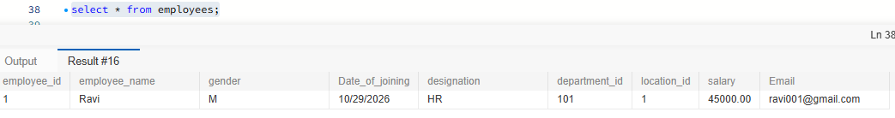

TRUNCATE TABLE employees;
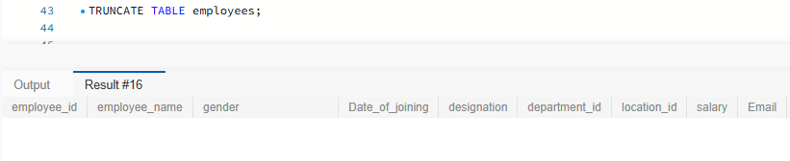
5. Database & Table Dropping (DROP): Write the SQL statements to drop the Employees table and then the “employee” database.
DROP TABLE employees;
DROP DATABASE employee;

Constraints :
1. Database Recreation:
⦿ Drop the 'employee' database if it exists and recreate it using the provided schema, ensuring that all tables are created with the appropriate constraints as instructed.
CREATE DATABASE Employee;
USE employee;
2. Departments Table:
⦿ Ensure that the "department_id" uniquely identifies each department.
⦿ Set up constraints on the "department_name" to avoid duplicate and null
entries.
CREATE TABLE Departments(
department_id int PRIMARY KEY,
department_name VARCHAR(100) NOT NULL UNIQUE
);
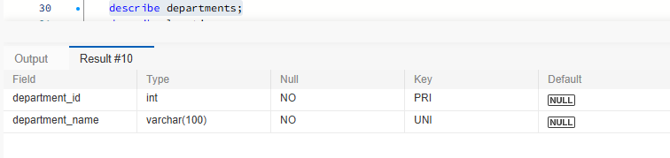
3. Location Table:
⦿ Establish a mechanism to automatically generate unique identifiers for each location, ensuring that they are incremented sequentially.
⦿ Implement constraints to prevent the insertion of null and duplicate locations.
CREATE TABLE Location(
location_id int PRIMARY KEY AUTO_INCREMENT,
location VARCHAR(30) NOT NULL UNIQUE
) ;
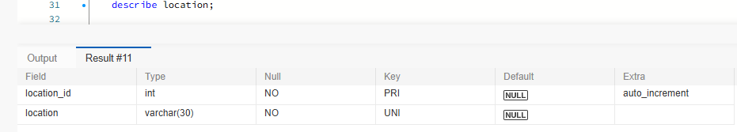
4. Employees Table:
⦿ Guarantee that each employee has a distinct identifier.
⦿ Create a restriction to ensure that the employee's name is always provided.
⦿ Limit the acceptable values for the "gender" field to only 'M' or 'F'.
⦿ Enforce a condition to ensure that the employee's age is 18 or above.
⦿ Automatically assign the current date to the "hire_date" field if not specified.
⦿ Establish links between the "department_id" and "location_id" fields in the "employees" table and their respective tables.
CREATE TABLE Employees(
employee_id int PRIMARY KEY AUTO_INCREMENT,
employee_name VARCHAR(50) NOT NULL,
gender CHAR(1) CHECK (gender IN ('M','F')),
age int CHECK (age>=18),
hire_date DATE DEFAULT(current_date),
designation VARCHAR(100),
department_id INT,
location_id int,
salary DECIMAL(10,2),
foreign key(department_id) REFERENCES Departments(department_id),
foreign key(location_id) REFERENCES Location(location_id)
) ;
